OOPS LAB

Experiment -4

NAME- ANMOL YADAV SAP ID- 500083814 ROLLNO- R214220178

**Question: 1**

1. Write a Java program to show that private member of a super class cannot be accessed from derived classes.

**Code:**

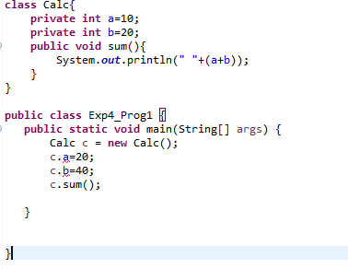

**Output:**

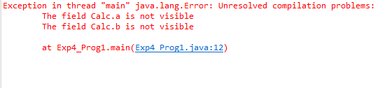

**Question: 2**

1. Write a program in Java to create a Player class. Inherit the classes Cricket _Player, Football _Player and Hockey_ Player from Player class.

**Code:**

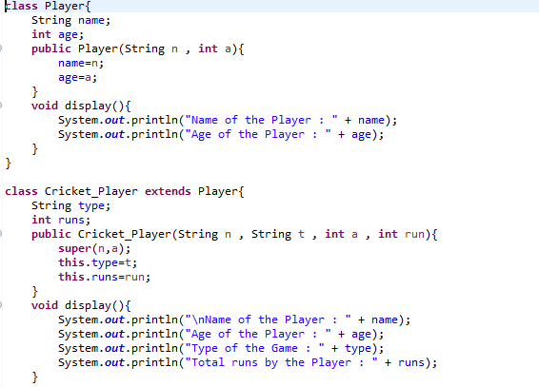

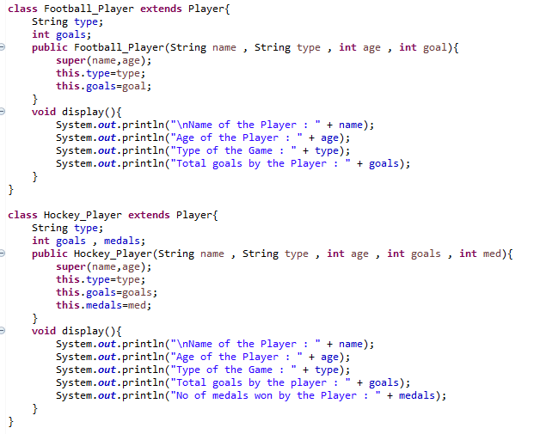

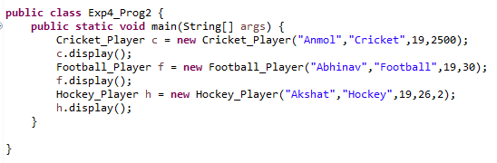

**Output:-**

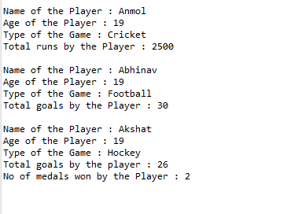

**Question: 3**

1. Write a class Worker and derive classes DailyWorker and SalariedWorker from it. Every worker has a name and a salary rate. Write method ComPay (int hours) to compute the week pay of every worker. A Daily Worker is paid on the basis of the number of days he/she works. The Salaried Worker gets paid the wage for 40 hours a week no matter what the actual hours are. Test this program to calculate the pay of workers. You are expected to use the concept of polymorphism to write this program.

**Code:**

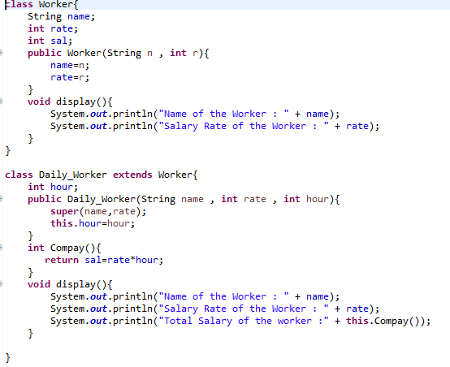

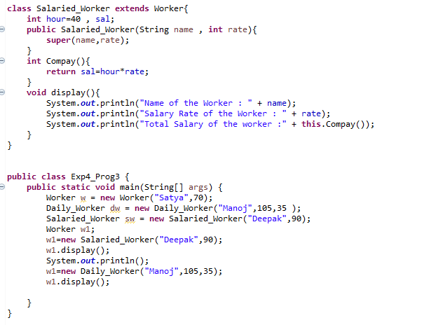

**Output:-**

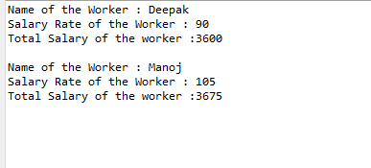

**Question: 4**

Consider the trunk calls of a telephone exchange. A trunk call can be ordinary, urgent or lightning. The charges depend on the duration and the type of the call. Write a program using the concept of polymorphism in Java to calculate the charges.

**Code:-**

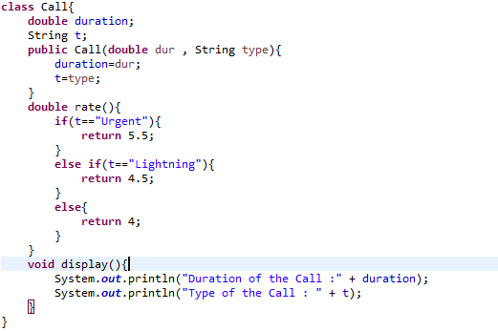

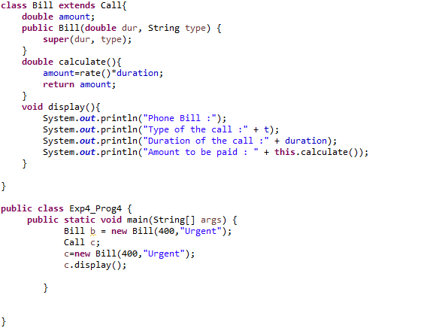

**Output:-**

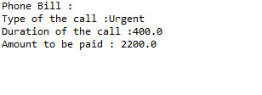

**Question: 5**

Design a class employee of an organization. An employee has a name, empid, and salary. Write the default constructor, a constructor with parameters (name, empid, and salary) and methods to return name and salary. Also write a method *increaseSalary* that raises the employee’s salary by a certain user specified percentage. Derive a subclass Manager from employee. Add an instance variable named department to the manager class. Supply a test program that uses theses classes and methods.

**Code:-**

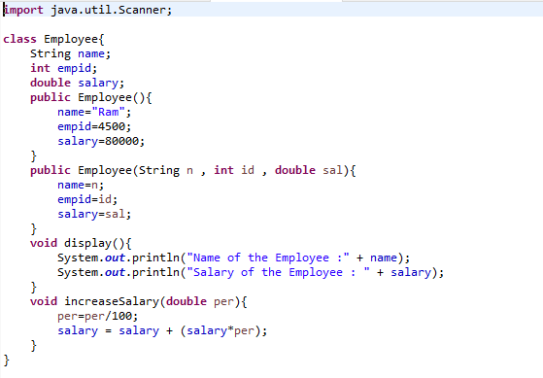

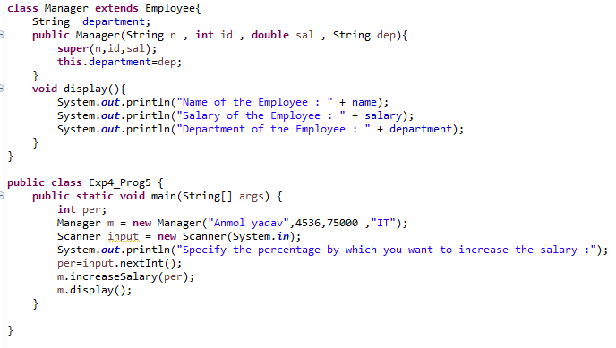

**Output:-**

